

**Ganadipathy Tulsi's Jain Engineering College**

Kaniyambadi - Vellore -632102

**TITLE:** Creating Blog Using WordPress Platform

**Category:** Digital Marketing

**Submitted By**

Team Leader : J. Arthi

Team Member 1 : E. Ashokkumar

Team Member 2 : B. Karan

Team Member 3 : K. Usman

Project Mentor Project Evaluator Project Spoc

Mrs. Priya Mrs. Priya Mr.D. Durai Kumar

**INDEX**

1.INTRODUCTION

1.1. Project Description

2.PROJECT PROCESS

2.1. Navigation

2.2. Search “WordPress Blog”

2.3. Select -Create a Blog

2.4. Sign Up and choose Domain.

2.5. Free Plan

2.6. Skip to Dashboard

2.7. Post-Add New Post

2.8. WordPress Blog-Title

2.9. Add subheading.

3.RESULT

3.1. Blog Link

4.ADVANTAGE

5.CONCLUSION

**1.INTRODUCTION**

**1.1 Project Description**

In this project, we aim to create a dynamic and user-friendly blog using the WordPress platform. Our goal is to design an appealing and responsive website that not only showcases compelling content but also offers a seamless user experience. We will customize the theme, configure essential plugins, optimize for SEO, and implement a user-friendly content management system, enabling effortless content creation and management. This WordPress blog will serve as a platform to share valuable information, engage with the audience, and establish an online presence effectively.

**2.PROJECT PROCESS**

**2.1. Navigation**

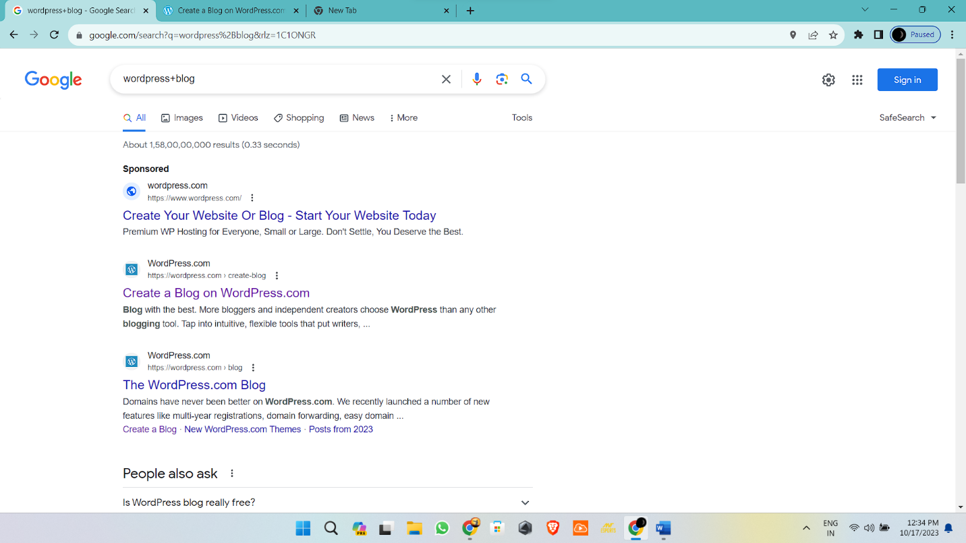

**2.2. Search “WordPress Blog”**

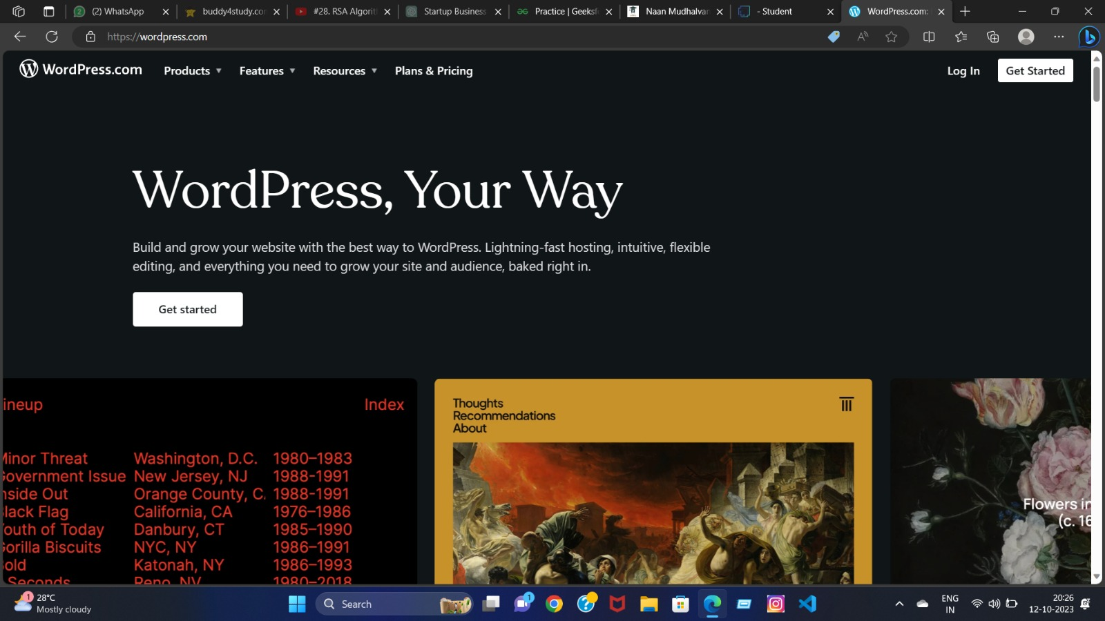

**2.3. Select -Create a Blog**

**2.4. Sign Up and choose Domain.**

**2.5. Free Plan**

**2.6. Skip to Dashboard**

**2.7. Post-Add New Post**

**2.8. WordPress Blog-Title**

**2.9. Add subheading.**

**3.RESULT**

**3.1. Blog Link**

[**https://biggestdogglobal.wordpress.com/2023/10/13/biggest-dog-global/**](https://biggestdogglobal.wordpress.com/2023/10/13/biggest-dog-global/)

**4.ADVANTAGE**

1. User-Friendly
2. Extensive Themes and Plugins
3. SEO-Friendly
4. Responsive Design
5. Content Management
6. Community and Support
7. Scalability

**5.CONCLUSION**

In conclusion, choosing the WordPress platform for creating a blog offers a wide array of benefits that make it a compelling choice for bloggers of all levels of experience. Its user-friendliness, extensive themes and plugins, SEO-friendliness, and responsive design capabilities provide the tools you need to craft an engaging and professional blog. Moreover, the robust content management system, strong community support, and scalability make it suitable for various blog sizes and purposes.